Phorto

What I really like about this one is mainly the nav bar. It has room for theoretically as many items as we’d like and we wouldn’t be construed for text length. For example, a nav item like “Proof Point: […]” with 20-30 characters would probably fit just fine.

You will see that I have labeled each of the sections below. Section 1 corresponds with the side bar (navigation), Section 2 corresponds with the “Home” (or header), and Sections 3, 4, 5, etc are the hypothetical sections that the site would scroll down to. See below in red:

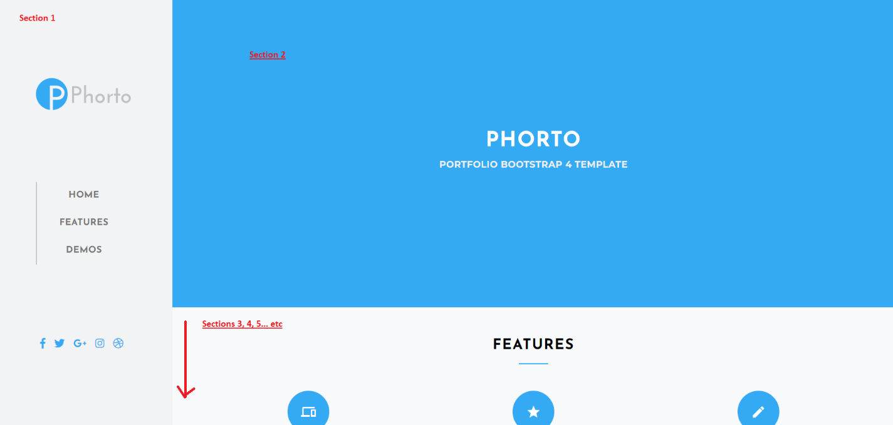

I’m thinking for Section 1… the Phorto logo can be replaced with the existing CSI logo and there can be clicakable nav links for each of the sections we have on the current site (i.e., Cyclical v. Defensive, A Proprietary Ratio, Perceived Market Risk, …, etc.).

Section 2 can be changed to a deep blue square (hex color code: #23567f) that says "Cyclical Strength Index" in the middle (in white font) – that should suffice for now.

Sections 3 – infinity:

What I like about this theme is the alternating background colors (see below)

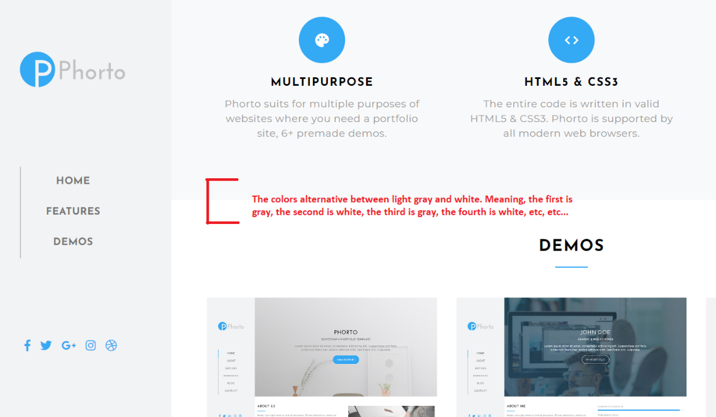

I imagine each of the existing sections of the current website will have its own section on this website (and the background colors for each subsequent section will alternate between gray and white).

For example:

“Cyclical v. Defensive” section will have a gray background;

“A Proprietary Ratio” section will have a white background;

“Perceived Market Risk” section will have a gray background;

“Market Position” section will have a white background;

“Time per Quadrant” section will have a gray background;

“Proof Points: Avoiding Q3” section will have a white background;

Etc, etc, etc…

For each of the amcharts, the background color should match the section’s background color. For example, if Time per Quadrant pie graph is in a section with a gray background, then we should change the background color within the amcharts code to also have a gray background.

Each of the above sections will have anchored links that can be clicked in the left scroll bar.

Geek

I conceptually picture this theme’s layout to follow a similar logic to that of Phorto. I will elaborate…

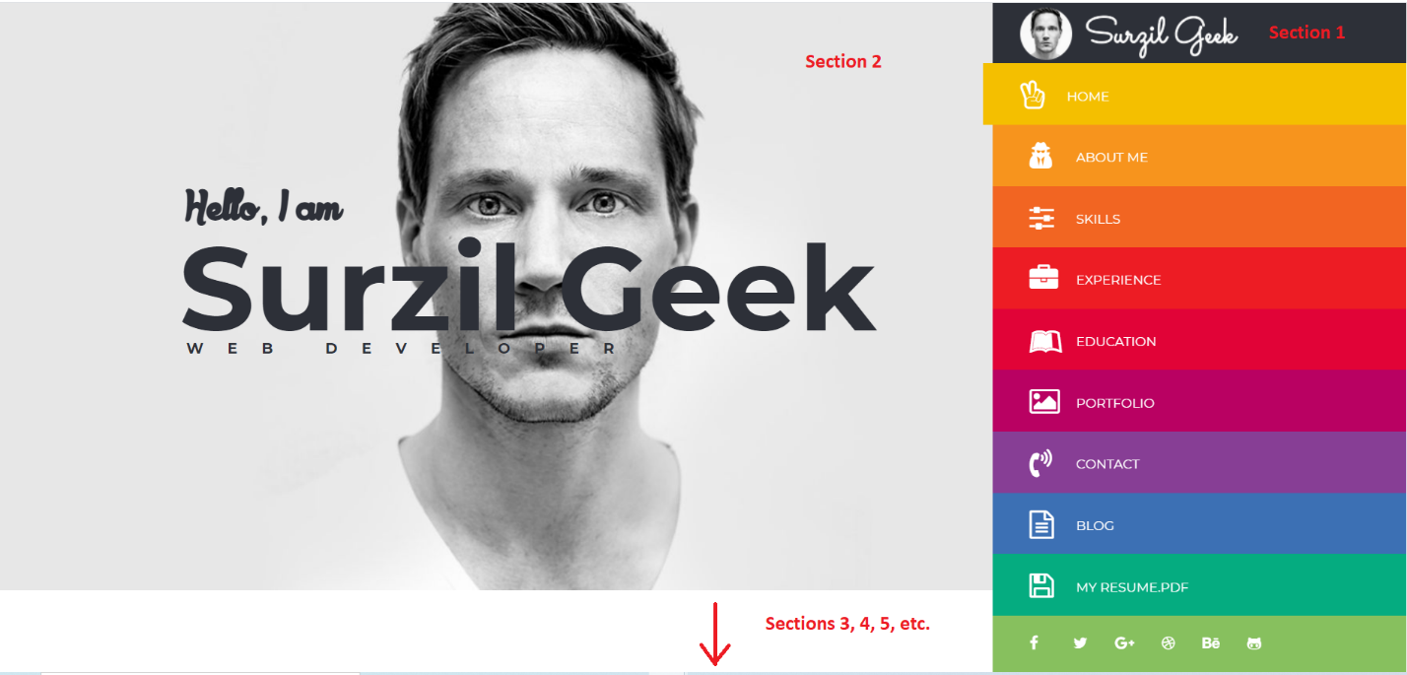

For Section 1… the image and writing above the nav bar can be changed to our existing CSI logo.

For Section 2 (the “Home” section) - just like the Phorto example, a deep blue square (hex color code: #23567f) that says "Cyclical Strength Index" in the middle (in white font) will suffice for now.

And then also like Phorto, this theme has alternating gray and white rectangular sections that help demarcate the borders of where each begins and ends. I imagine each of our existing website sections can similarly fit within either a gray or white background rectangle. Additoinaly, each of these sections I imagine having its own clickable nav link in the nav bar (e.g., Cyclical v. Defensive, A Proprietary Ratio, Perceived Market Risk, …, etc.).

Just like Phorto, for each of the amcharts, the background color should match the section’s background color.